Chapter 2 Programming Language Syntax

How do we describe the token grammar of a language?

- Natural languages are often ambiguous.
Ex., He hit the wall with his head and it broke.

- Grammar used for Programming languages must be precise,
  - So that the computer program can understand.
  - Precise both in terms of syntax and semantics

Q. What are different ways we could describe a language’s syntax and/or semantics?
  - Books and menus – detailed but imprecise
  - Schema diagram (ex., Pascal syntax diagram) – precise, but not in a computer ready form.
  - Formal grammar: Regular Expression (RegEx), CFG,
  - Computational model: Finite Automata (FA), PushDown A (PDA), TM

    - Token and Regular Expressions

Token
- The basic building block of programs
- The shortest string of characters with individual meaning
- Examples: +, SIUe, {, identifier …
- Identifier can take many forms ex., foo, linkedList, count1, 123siue(?)

Tokenization - From char stream to token stream
Scanner – a program module that turns a char stream into a token stream.

Since tokens can take many shapes and forms, how do we characterize them in general?
More importantly, who should be writing the scanner code?

To specify grammar rules for a token language concisely and formally, we could
- Use the notation language called regular expression - a pattern describing a certain amount of text. Example:

// c++ example statement
int A = 122*SIUE + “closed” ; // there is type-mismatch error

What are the tokens?

int | A | = | 122 | * | SIUE | + | “closed” | ;

Does the scanner see an error?

No, cuz there are all legit token.

- Or use a Finite Automata, a type of computational model. (Call CT1.ppt)

Both above define regular language.

Syntactically, a regular expression (or simply written as RegEx) is one of the following:
- The empty string, denoted by ε
- A single character in the alphabet ∑ (Example of ∑ : {0,1}, {a, b, c}, {a-z})
- Two regular expressions concatenated with º (often omitted, try not to use other symbols you may have seen in script languages such as &), ex., 0 º 1, 01
- Two regular expressions separated by | (i.e., union, or other possible symbols: U), ex., 0|1, 0U1
- A regular expression (in parenthesis if more than one symbol) followed by the Kleene star (repeating zero or more times), ex., (regex)*

Ex., (0|1)*00 any bit sequence that end with two 0s

Alternatively, we could represent it as: ∑*00
// also means any binary number that’s multiple of 4

Definition of Regex

- Use a set of rules:

Name (of concept or pattern) regex // production rule

Example – the syntax for a number accepted by a hand-held calculator on alphabet ∑={0-9}, can be defined with this rule set (Example 2.3):

number integer | decimal
integer digit digit* // or digit⁺
decimal digit* (digit. | .digit) digit* // a RegEx using book definition
// the simplest decimal is 9. Or .5

digit 0 | 1 | 2 | 3 | 4 | 5 | 6 | 7 | 8 | 9 // often written as 0-9,

- we could combine the 3-rule sequence into a single regex:

digit digit* | digit*(digit. | .digit) digit* // typical form of a RegEx

We can apply the rules to derive any real number, ex., 3.14

number
-> decimal
-> digit*(digit. | .digit) digit* // first * repeating 0 times
-> digit . digit digit* // 2nd * repeats once
-> digit . digit digit
-> 3. digit digit
-> 3.1 digit
-> 3.14

The LHS of rules contains concepts, they are either
- The main concept we are defining (ex., number), or
- Intermediate terms/concepts

Multiple rules can often be combined into a single rule, ex.,

number Σ⁺ | Σ* (Σ. | .Σ) Σ *

Integer (0-9)⁺ // This is often done in regex

Regular expression captures the pattern of data string using 3 basic regular operators:
Concatenation ( º ),
union (|),
Kleene star (*).

What’s special about these three operators?
They are closed under Regular Language NFA

continue with CT1.ppt for proof

Are there other regular operators?

What are they?

How is regex related to FA?

Examples - Write regular expressions for the following languages. The alphabet for A-C is ∑={0,1,2,3,4,5,6,7,8,9} (0-9)

- Words that begin with substring 911 and has exactly 10 digits

911∑⁷

- Words of length 3

∑³

- numbers that contain exactly three 1s

(0|2-9)* 1(0|2-9)* 1(0|2-9)* 1(0|2-9)*

- Identifiers - words that starts with a letter, followed by any number of letters and digits

(a-z|A-Z)(a-z|A-Z|0-9)*

- Passwords - 8 or more characters with at least a digit and a letter

Not easy using only union, concatenate and star

Easier to write in extended regex used in most modern programming languages either built-in (ex., perl, ruby, awk), or with library (java, c++, etc)
Example, perl regex (http://www.somacon.com/p127.php )

Possible solution in perl regex
^(?=.*[a-zA-Z])(?=.*\d)(?=.{8,})$

^ start
?= match
. ∑
$ end

This is not standard regex

We could represent this by using intersect ∩

∑⁸∑* ∩ ∑*(a-z|A-Z)∑* ∩ ∑*(0-9)∑*

We could use FA

We can also change this to another regex which only uses union, concatenate and star, by first changing this to DFA.
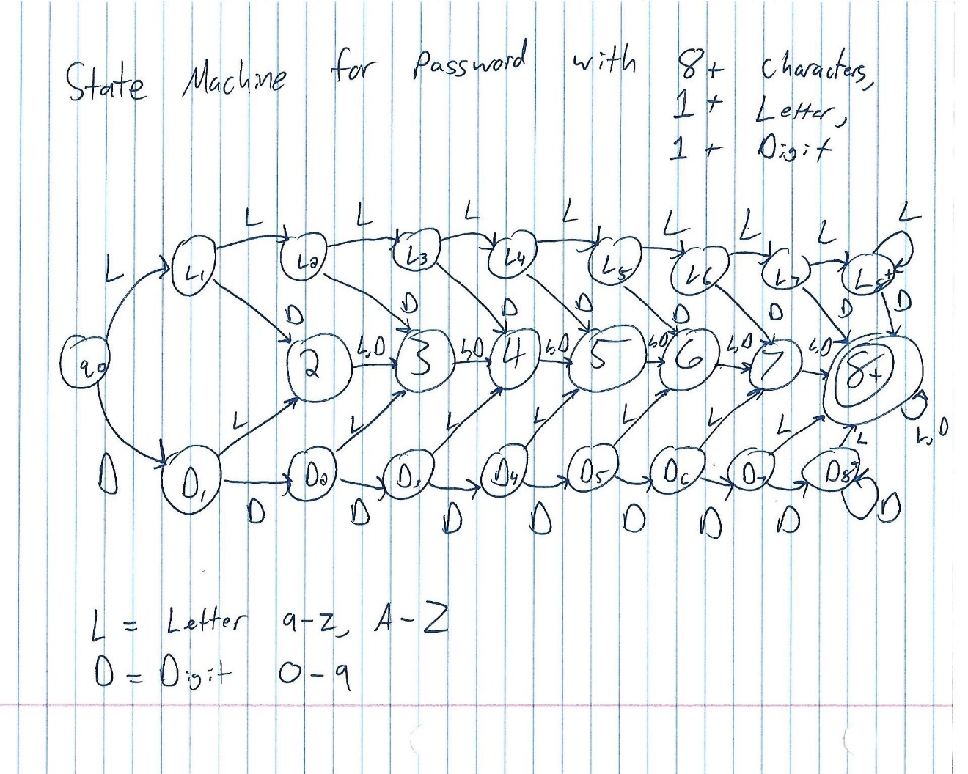

2.2 Scanning

A scanner is responsible for
- tokenizing source
- removing comments // probably done during preprocessing
- saving text of identifiers, numbers, strings
- saving source locations (file, line, column) for error messages

Example 2.9 – a simple calculator language

Regex (rules) for tokens:

Assign :=
Plus +
Minus -
Times *
Div /
Lparen (
Rparen )

ID letter (letter | digit)* // except for read and write
number digit digit* | digit* ( . digit | digit . ) digit*
comment /* (non-* | * non-/)* */
| // (non-newline)* newline

Note that non-* represents any char except *, the same goes for non-/, non-newline, etc.

How would you implement a token scanner in C++?
What control structure? Array (vector) and extended if else or switch

Figure 2.5 – Outline of an ad hoc scanner code in C-type of syntax

// this code recognize one token

// Skip white spaces;

Getc(fin, curChar);

While (isspace(curChar)) // cctype

Getc(fin, curChar);

// at this point curChar contains non-space char
if (strchr(curChar, “()+-*”) // check to see if curChar is a member of the string
return lookUpToken(curChar) ;
// look up existing or create new entry in token (i.e., symbol) table if not found

else if (curChar==’:’) // must be :=
{
getc(fin, nextChar);
if (nextChar==’=’)
return assign
else
ferror << “error\n”;
}
else if (curChar==’/’) // could be: /* // or /
{
getc(fin, nextChar);

if (nextChar==’/’)
while(nextChar!=’\n’)
getc(fin, nextChar); // skip until end of line
else if (nextChar == ‘*’)
{
while(!(curChar==’*’ && nextChar==’/’)
{ curChar=nextChar; getc(fin, nextChar);
}

Else // / is not followed by / or *
Return div; // lookUpToken is not necessary
}
Else if (curChar==’.’)
{
getc(fin, nextChar);
If (isdigit(nextChar)
{
While (isdigit(nextChar))
getc(fin, nextChar);
… // package the number
Return number;
}

Else
ferror << curChar << “error\n”;
}
Else if (isdigit(curChar))
{
While (isdigit(nextChar))
getc(fin, nextChar);
If (nextChar==’.’)
While (isdigit(nextChar)) getc(fin, nextChar);
… // convert it from string to number
Return number;
}
else if (isletter(curChar))
{
string id;
While(getc(fin, curChar) && isalpha(curChar)) // curChar is letter or digit
{
id = id+curChar; // make string
}
if (id== “read ” || …) // check for special symbols
return getToken(id);
else

Return tokenLookUp(id)
}

Else
Ferror << “error\n”;

Algorithm can be represented as a flow chart:
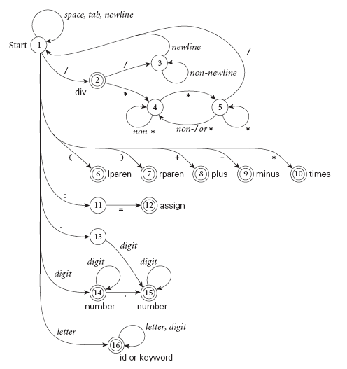

This is a Deterministic Finite Automaton with dead-end state omitted.

Comments
- Programs such as Lex (lexsical analyzer generator?), yacc (yet another compiler compiler), and ANTLR (ANother Tool for Language Recognition) are scanner generators (or more), that build scanner code automatically from a set of rules given in the form of regular expressions (and CFG for parser code).

- These program (implicitly) construct a min DFA from a language description in the form of Regex (Or similar), and then use the mDFA as a basis for generating the scanner code. Specifically,

Regex NFA DFA min DFA code

This min DFA could have any number of states depending on the particular language.

2.2.1 Generating a min DFA (from regex)

For basics of finite automata, see CT chapter 1 (CT1.ppt )

Regular expression minimized DFA
The algorithm (i.e., a step-by-step solution):
3 easy steps:
  - regular expression to NFA (This is also part of proof for Regex==FA)
  - NFA to DFA
  - Minimizing DFA

Step 1 Regular Expression to NFA

Simple forms:
- The NFA representing the empty string is:
- If the regular expression is just a character, e.g. a,
then the corresponding NFA is :
- The union operator is represented by a choice of transitions from a node; thus a|b can be represented as:
- Concatenation simply involves connecting one NFA to the other; e.g. ab is:
- The Kleene closure (or star) must allow for taking zero or more instances of the letter from the input; thus a* looks like:

A more general form (figure 2.7)

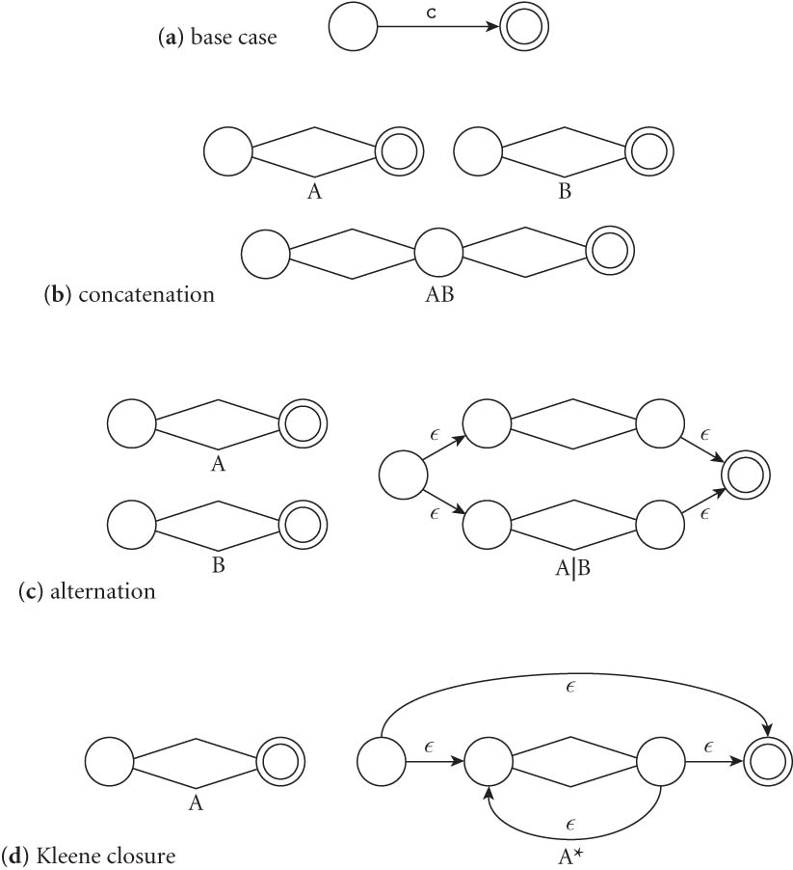

Example (Figure 2.8) – Use these rules to build a NFA for the Language of all decimal numbers, from bottom up

Regex: d* (.d | d. ) d*
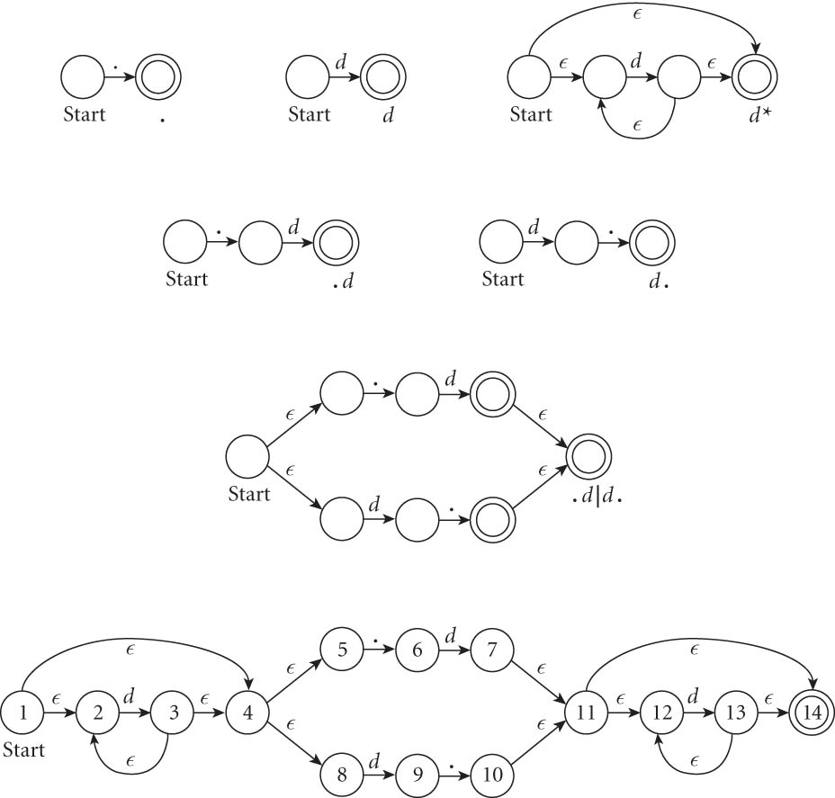
Start state of NFA: 1
Step 2: NFA to DFA
// How to describe transition from the new state? Use move

Step 2: NFA DFA
- Each state in the newly created DFA represents a subset of states in the original NFA
- Each transition of the new DFA, must account for all transitions from all NFA states this DFA is representing – use move function as defined below
- We also have to account for ε transitions in NFA – use the closure function as defined below

Key operations - two important functions:

- The function closure takes a state and returns the set of states reachable from it with ε-transitions.
Ex., closure(1) = {1,2,4,5,8}
Closure(6) = {6}
Closure(7) = {7, 11, 12, 14}
Note that this set will always include the state itself.
  - We should be able to get from a state to any state in its -closure without consuming any input.

- The function move takes as input a (newly created) DFA state and an input character and returns the set of states (from original NFA) reachable by one transition on this character. This set is then matched/mapped to an existing state in the DFA or created if it doesn’t exist.

We can generalize both these functions to apply to sets of states by taking the union of the application to individual states.
E.g. If 1, 2 and 3 are states of NFA, A[1,2,3] is a state in the DFA that represent those 3 states.
move( A[1,2,3],’b) // A is a DFA state representing 1,2,3 of the original NFA
= closure(move(1, ‘b)) U closure(move(2, ‘b)) U closure(move(3, ‘b))

The Subset Construction Algorithm (From NFA to DFA)
- Create the start state of the DFA by taking the -closure of the start state of the NFA. Ex., start state of DFA is Closure(1) ={1,2,4,5,8 }

- Perform the following for every DFA state(s):
For each possible input symbol:
  - For each state represented by the newly-created state, apply move on it and the input symbol; this will return a set of states, one from each move
  - Apply the -closure to this set of states, possibly resulting in a new set.
  - This set of NFA states will be a single state in the DFA (create if necessary), to which the transition will now lead.

Ex., Move({1,2,4,5,8}, d)
= closure(move(1,d)) U closure(move(2,d)) U
closure(move(4,d)) U closure(move(5,d)) U closure(move(8,d))
= {}U {2, 3,4,5,8} U {} U {} U {9}
= {2,3,4,5,8,9}

- Each time we generate a new DFA state, we must apply step 2 to it. The process is complete when applying step 2 does not yield any new states.
- All DFA states that contains an accept state in the original NFA is a accept state.
- The accept states of the DFA are those which contain any accept state(s) of the original NFA.

Note: the newly created DFA does not necessarily needs the dead-end state as it does not affect the final result.

Resulting DFA
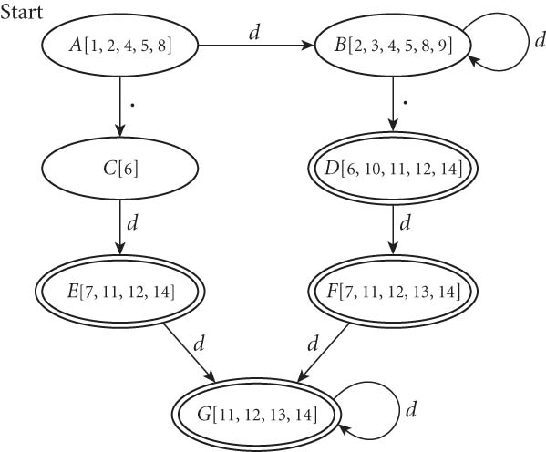

Step 3 – minimize DFA

- Place states into two equivalence classes: accept states and non-accept states
- Repeatedly break the classes by looking for ANY input symbol which cause the transition from one equivalence class to multiple equivalence classes.
Ex.,

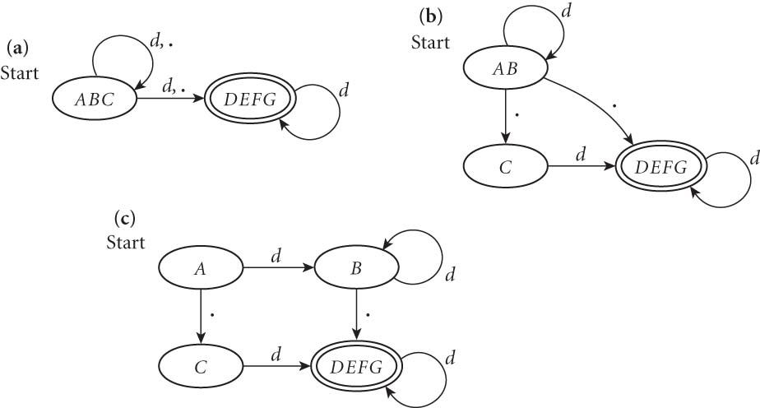

2.2.2 Generating Scanner Code
Scanner functions can be built with 3 different approaches:

Approach 1. ad-hoc (manually)
- Written specially for *this language
- Code does not rely on state machine (i.e., FA), ex., if … else if … code
- Generally yields the fastest, most compact code by doing lots of special-purpose things.

Approach 2. semi-mechanical (manually or by program such as yacc), based on DFA, usually realized as nested case statements, ex.,

int curState = 1; // start state
// …
// 14 = integer recognized
// 15 = decimal recognized
// 16 = identifier recognized
// …
while (fin.read(curChar)) // while not EOF, read one char
{
switch (curState)
{
case 1:
switch (curChar)
case ‘\t’: case ‘ ‘: case ‘\n”: curState = 1; // skip
…
case ‘0’..’9’: // start of new token, move
rememberState = 1; // for recovery
curState = 14; // start of a number
case ‘a’...’z’: ‘A’..’Z’:
rememberState = 1; curState = 16;
id += curChar; // id is a string
// start of a identifier
break;
…
case 16:
switch (curChar)
case ‘a’..’z’:
\ case ‘A’..’Z’:
case ‘0’..’9’: // continue
id += curChar; // append curChar to id
curState = 16;
case ‘\t’: case ‘ ‘:
case ‘+’: case ‘-‘:
…. : // current id is completed,
// proceed to recognize
putc(curChar); // put curChar back
// since it’s not part of cur token
return tokenTable(id); // return id tag
Default: // error
Print(“error code\n”)
curState = rememberState; // skip current token
…
break;
…
}
}

The ID recognition state (i.e., 16) always return the longest-possible tokens

    - When does the current token ends and we proceed to the next token?
- Recognize only when the next character cannot be part of current token (look ahead of one symbol)
  - the next character will generally need to be saved (or pushed back onto input buffer) in case it’s part of the next token,
e.x.,
siuE:=12345;
we recognize siue as a identifier when we see the :,
we need to save ‘:’ since it could be part of the next token.

Many times, this only requires 1 char look-ahead, i.e., linear

- In some cases, we may need to perform >1 character of look-ahead in order to know whether to proceed. Ex., when you have 3.
  - do you proceed (in hopes of getting 3.14)?
or
  - do you stop (in fear of getting 3..5)?
In this case, one symbol look-ahead is not enough, we need 2

This example only requires 2 char look ahead, similar to that of // vs /* vs /
Two character lookahead is OK

- Some language presents messier cases, in which any fixed amount of look-ahead will not work. Ex., Fortran
DO 5 I = 1,25 loop
DO 5 I = 1.25 assignment
  - Here, we need to remember we were in a potentially final state, and save enough information that we can back up to it, if we get stuck later

    - What do we do with keywords and reserved words?
Treat them as exception, to be handled after a token is recognized, via a look-up table

    - In the switch code, what two pieces of info are used to determine the proper action and next state? curState, curChar

How else can we code it by using these two pieces of information?

Approach 3. Table-driven DFA program – This is almost always done by a program (ex., lex)
  - Represents the automaton as a 2d table (ex., scanTab) of curState (row) and curChar (column), where each entry describes possible actions:
    - Continue reading input for the current token
    - Recognize – end of a token is recognized with help of another table such as tokenTab. It looks up keyword and update token table before starting another token
    - Move to a new state at the end of current token
    - Error – print and ignore

Limit of Regular Expression

- does not allow recursive definition (either directly or indirectly)
- cannot be used to define nested structures, such as
  - exp exp+exp | exp-exp | exp*exp | exp/exp | ( exp )

How do we know that is true?

See proof on page 113 of CT1.ppt

So, what’s the next level?

2.1.2-2.1.3 Context-Free Grammars (CFG) and parse tree

CFG
- Defined by Noam Chomsky of MIT
- Also referred to as Backus-Naur Form (BNF) as the two are almost identical.
- BNF was invented by John Backus, modified by Peter Naur
- A popular method for describing syntax grammars of programming languages, very precisely.
- Use (recursive) rules to describe concepts/abstractions.

General form of the rules:

LHS RHS, Ex.,

S aSb | ε // a^{n}b^{n}

S => aSb => a aSb b => aaεbb => aabb

LHS: Var representing the concept being defined, there is only one Var on LHS in CFG
RHS:
- often contain a mix of variables and terminals,
- Explanation and expansion of the concept in terms of
Lexemes, tokens (class of lexemes), and other concepts.
Ex.,
<assgStmt> <var> = <expression>;

In general, a CFG is a 4-tuple (T, N, S, R), consisting of
  - A set of Terminals (or Token) T (also represented as ∑)
  - A set of Non-terminals N (or V for variables)
  - A Start symbol S (a non-terminal, thus part of N, this is the top-level concept), it’s the root of the parse tree.
  - A set of productions rules R

Ex., CFG for the if statement (PASCAL)

<if-stmt> if <logic-expr> then <stmt> // rule 1

| if <logic-expr> then <stmt> else <stmt> // rule 2

If, then, else are terminals

Is there any recursion in the <if-stmt> rule? No, not directly

But yes indirectly, because you would expect to see a rule for <stmt> somewhere else in the grammar, which has <if-stmt> on the RHS

<stmt> <while-stmt> | <for-stmt> | … | <if-stmt>

Another Example:

CFG for variable-length list (i.e., a list that could repeat any number of times)

E.G., variable declaration in PASCAL and many other languages

Informally, we could use (and often does) …
<type> <identifier>, <identifier>, … ;

Formally, CFG uses recursive rules to define variable-length list

Ex.,
<var-declaration> <Type> <identifier-list>;
<identifier-list> <identifier> | <identifier>, <identifier-list>

<identifier> A..Z | a..z // for simplicity, we use single letter ID

Left-most derivation of A, B, C – we always expand the left-most Var

<identifier-list>
= <identifier>, <identifier-list>
= A, <identifier-list>
= A, <identifier>, <identifier-list>
= A, B, <identifier-list>
= A, B, <identifier>
= A, B, C

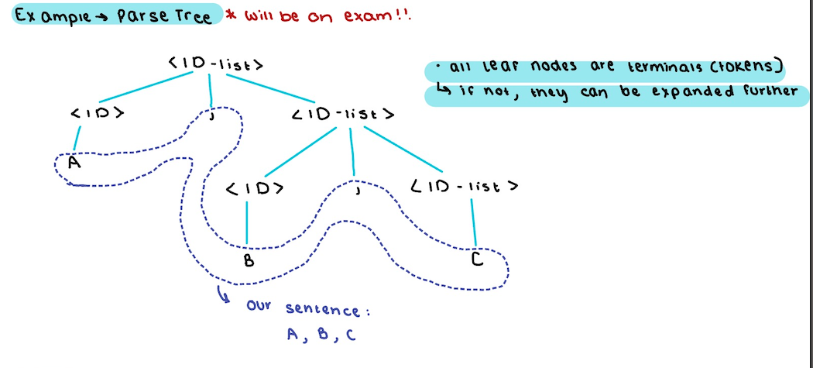

Since we are able to create a parse tree for this sentence (A,B,C), we showed that the sentence belong to the ID-List Language.
In addition, the parse tree also shows the syntactic structure of the sentence.

A CFG rule is said to be:

- Left recursive – LHS Var appears at the beginning of RHS.
<concept> <concept> terminals

- Right recursive – LHS Var appears at the end of RHS.
<concept> terminals <concept>

A sentence (or paragraph) is a sequence of terminals (i.e., a sequence of tokens) - this is something a parser takes as input

Derivations – the generation of a sentence, obtained by applying a sequence of rules until the string is entirely made of terminals, beginning with the start symbol.

Some applications of CFG (either by us or a program)

(a) Generate random sentence(s) by (repeatedly) applying rules

(b) Given a sentence, create a derivation to show that it belongs to the language

(c) Create a parse tree for a given sentence to
(i) Show it belongs to the language, i.e., the input is syntactically correct
(ii) Illustrates the syntactic structure of the given sentence

Example 2B – A CFG for a simple assignment statement

<ASSIGN> <id> := <expr>
<id> A..Z
<expr> <expr> + <expr> | // this is both left and right recursive
<expr> - <expr> | // this could be bad news
<expr> * <expr> |
<id>
Notation:
< > indicates non-terminals
<assign> is the start symbol for this set (i.e., it’s the top-level concept)
A..Z + - * := are terminals

An example leftmost derivation for A := B+C

<assign>

=> <id> := <expr>

=> A := <expr> // Why A? Because we looked at the input, i.e., 1 token lookahead.

=> A := <expr> + <expr> // why not just <id>? Because we peeked at the next 2 tokens

=> A:= <id> + <expr>

=> A:= B+<expr>

=> A:=B+<id>

=> A:=B+C

Derivation: one rule application at a time.

Leftmost derivation – always replace the leftmost non-terminal first.

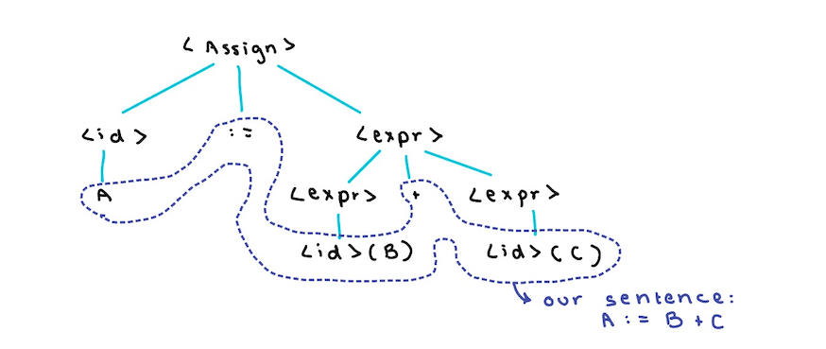

HW1C

      - Derive the sentence A := A – B * C using leftmost derivation and draw the corresponding parse tree

<assign>
<id> := <expr>
A := <expr>
A := <expr> * <expr>
A := <expr> - <expr> * <expr>
A := <id> - <expr> * <expr>
A := A - <expr> * <expr>
A := A - <id> * <expr>
A := A - B * <expr>
A := A - B * <id>
A := A - B * C

The corresponding parse tree

<assign>

<id> := <expr>

A <expr> * <expr>

<expr> - <expr> <id>

<id> <id> C

A B

Q. What does this parse tree tell us? A := [A-B]*C i.e., we are doing A-B first

The parse tree tells us how the sentence would be evaluated, which is recursive by nature, i.e., evaluation/computation is done bottom up.

This tree interprets the sentence as A:=(A-B)*C

Is this wrong? NO

We could also use <expr> <expr> - <expr> before * resulting in a different sequence (i.e., derivation) :

<assign>
<id> := <expr>
A := <expr>
A := <expr> - <expr>
A := <id> - <expr>
A := A - <expr>
A := A - <expr> * <expr>
A := A - <id> * <expr>
A := A - B * <expr>
A := A - B * <id>
A := A - B * C

<assign>

<id> := <expr>

A <expr> - <expr>

<id> <expr> * <expr>

A <id> <id>

B C

This tree represent/interpret the sentence as A := A – B*C

Ambiguous grammar – a grammar is ambiguous if, for the same sentence,
- There are 2 or more distinct parse trees, resulting in 2 or more interpretations.
- There are 2 or more leftmost derivations.
Ex., A := A – B * C

Here are the two possible interpretation/evaluations from this grammar 2B:

A := [A-B]*C

A := A-[B*C]

How do we know which one is appropriate?

Language often has additional (and hidden) rules for resolving ambiguity, ex.,

Operator Precedence (* over +, -) and associativity (left to right)

- Two distinct parse trees operator precedence/associativity is not well defined
- Operator precedence/associativity is hidden somewhere else
- To create the parser automatically, precedence/associativity info needs to be incorporated into grammar explicitly

What we need?

A new and better grammar with operator precedence and associativity clearly and unambiguously specified unique parse tree for each sentence.

Note that operators at a lower level of the unique parse tree have higher precedence than the operator at higher level.

Let’s fix precedence first!!!!

-------------------------------------- * over + and - ---------------------------------------

<assign> <id> := <expr>
<expr> <expr> + <expr> |
<expr> - <expr> |
<term> // Exp Rule

<term> <term> * <term> |
<term> / <term> |
<id> // Term Rule

Try A := A – B * C

<assign>

<id> := <expr>

A <expr> - <expr>

<term> <term>

<id> <term> * <term>

A <id> <id>

B C

What about associativity?

Is this grammar left and right recursive?

Try A := B – C - D

Associativity is undefined (see board)

Fix it!!!!!!!!!!!!!!!!!!!!!!!!!!!!

How? Make the rule left recursive

<expr> <expr> + <term> |
<expr> - <term> |
<term>

<term> <term>*<id> | <id>

Goal: Each sentence in an unambiguous grammar has a unique parse tree.

In General, for expression rules

- Left recursive left associative
- Right recursive right associative

Operator associativity:

+ left
- left
* left
/ left
^ (exponentiation) right

How do we add ^ operation?

      - Make it right recursive

<factor> <id>^<factor> | <id>

  - Also change * rule from:
<term> <term>*<id> | <id> // before
To
<term> <term>*<factor > | <factor> // after

Add () rule:

Change ^ rule to:

<factor> <Expo>^<factor> | <expo> // <expo> represents the concept of exponent
<expo> <id> | (exp)
<expr> <expr> + <term> |
<expr> - <term> |
<term>

<term> <term>*<factor> |
<term>/<factor> |
<factor>

<factor> <expo>^<factor> | <expo>

<expo> <id> | (<exp>)

EBNF – know what they represent and don’t need to use this notation

- Increased readability and writability
- Same descriptive power

The additions:

- Use [ ] to describe optional components.
([ ] is often see in language manuals, ex., mysql select statement
Ex.,
<if-stmt> if <logic-expr> then <stmt> [else <stmt>]

Compare and contrast with

<if-stmt> if <logic-expr> then <stmt>
| if <logic-expr> then <stmt> else <stmt>

- Use ( )* for repeating 0 or more times.

Ex.,

<identifier-list> <identifier> (, <identifier>)*

same as
<identifier-list> <identifier> | <identifier>, <identifier-list>

What about ?

<identifier-list> (<identifier>, <identifier>)*
^
|
Is this correct? No and we can confirm/determine by doing a derivation.

- Use ( | ) to describe multiple choice options.

Ex.,
<expr> <expr>*(A|B|C)

same as

<expr> <expr>*A | <expr>*B | <expr>*C

same as
<expr> <expr>*<id>
<id> A|B|C // A-Z

Goto CT2.ppt for Recap/review of CFG and introduction of PDA

Return from CT2.ppt
  - Parsing

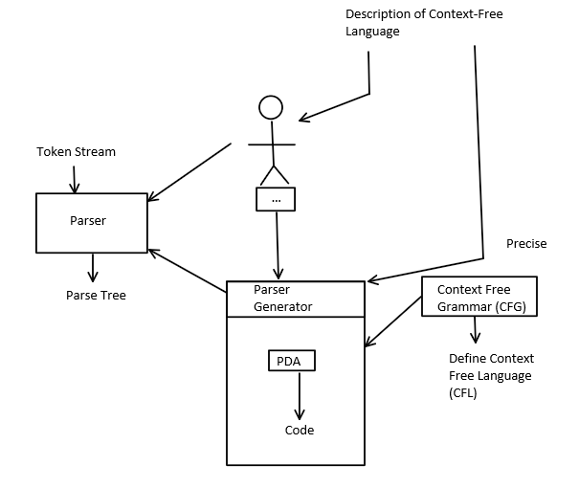
- A parser is a language recognizer
  - Created from a given CFG, created by A person or program)
  - It determines the syntactic structure of a given sentence by creating a parse tree.
  - It also determines whether sentence belongs to the language as defined by the CFG.

- There are many grammars for every context-free language,
  - NOT all grammars are created equal, some are more elegant, easier, or more efficient to use.
  - For any CFG, we can create a parser that runs in O(n³) time. Ex.,
- Earley's algorithm – dynamic programming
- Cooke-Younger-Kasami (CYK) algorithm (LR)

- Is O(n³) time good for a parser in a compiler?
  - What is N here? N is the number of tokens of a complete sentence in the particular language. It could be a complete program of a HL language .

- Luckily, there are large classes of grammars for which we can build parsers that run in linear time. The two most important classes of parsers are called LL and LR

- LL stands for 'Left-to-right, Leftmost derivation'.
  - LL parsers are also called 'top-down', or 'predictive' parsers
  - From start symbol to token symbols…
Top-down to create a parse tree

- LR stands for “Left-to-right, Rightmost derivation’.
  - LR parsers are also called 'bottom-up', or 'shift-reduce' parser.
  - From token stream to start symbol, backwards.
  - When the derivation is done, it looks like a rightmost derivation in reverse order.

- LL or LR are usually written with a number in parentheses after it, indicating how many tokens of look-ahead (including current) are required in order to parse the input
  - Almost all real compilers use (at least) one token look-ahead
- Additional properties:
  - Every LL(1) grammar is also LR(1), though right recursion in production tends to require very deep stacks and complicates semantic analysis
  - Every CFL that can be parsed deterministically has an Simple LR(1) grammar
  - Every deterministic CFL with the prefix property (no valid string is a prefix of another valid string) has an LR(0) grammar.

Comparing and Contrasting LL and LR with an example – a grammar for identifier list (figure 2.20)

Rules, Associativity, and Parsing – Examples

Ex of left-recursive rule: E -> E+T | T // this supports left associative rule,
// LR(1) friendly, LL(1) impossible

Ex of right-recursive rule: E -> T+E | T // this supports right associative rule, so
// so It is wrong for left-asso Ops such as + *
// LL(1) friendly, LR(1) unfriendly
What about this rule:
T -> (E) // this neither left nor right recursive

ID List rules:

id_list id id_list_tail
id_list_tail , id id_list_tail
| ;

id ‘A’..’Z’

Note that this grammar is right recursive! good for LL(1) parser

LL derivation is easy:

id_list
- id id_list_tail
- A id_list_tail
- A, id id_list_tail
- A, B id_list_tail
- A, B, id id_list_tail
- A, B, C id_list_tail
- A, B, C;

At each step of the derivation/parsing process, LL(1) parser picks one to further expand. It bases its decision on the following:
(a) current input token (ex., “,”)
(b) current left-most non-terminal which we are replacing (ex., id_list_tail)
(c) the beginning of the RHS of the production rule

LL Parsing LR parsing

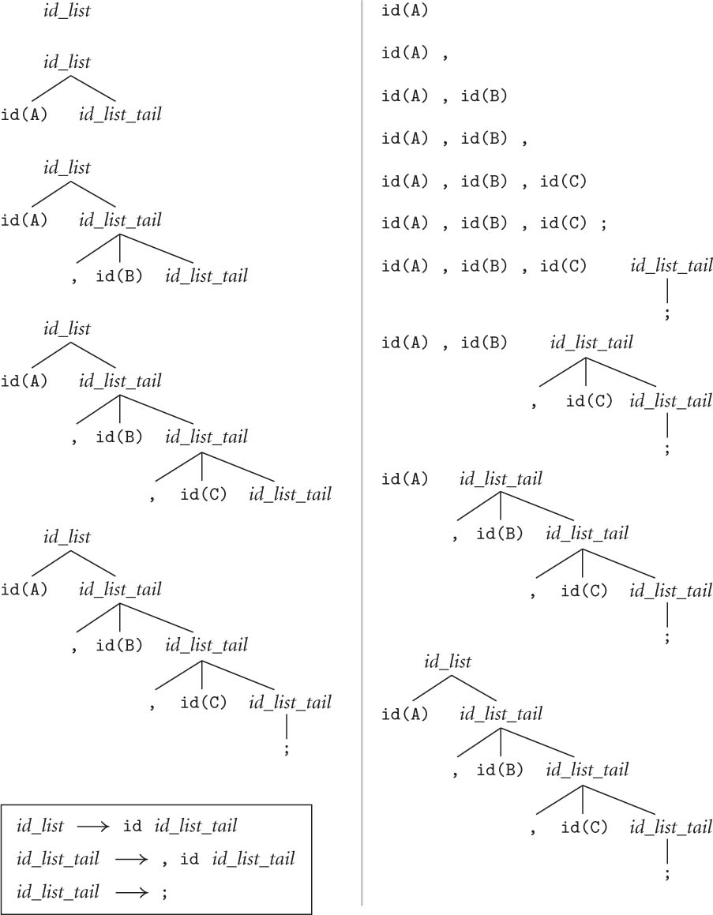

LR build the tree bottom up, it uses the grammar rules in reverse order – reducing the RHS to the corresponding LHS

So, what did we learn from this example?

LL(1) parsing better than LR(1) parsing? No, it’s better for this CFG because the grammar is right-recursive, IE., this is a LL(1) grammar.

- LL and LR generate the same tree – Whether its derivation is leftmost or rightmost does not affect the tree, just different process.
- This grammar is right recursive (also called tail recursive: IDT , ID IDT) which is Good for LL parser, less so for LR (though still doable)

To make it easier for LR parser, we could change the grammar to left recursive:

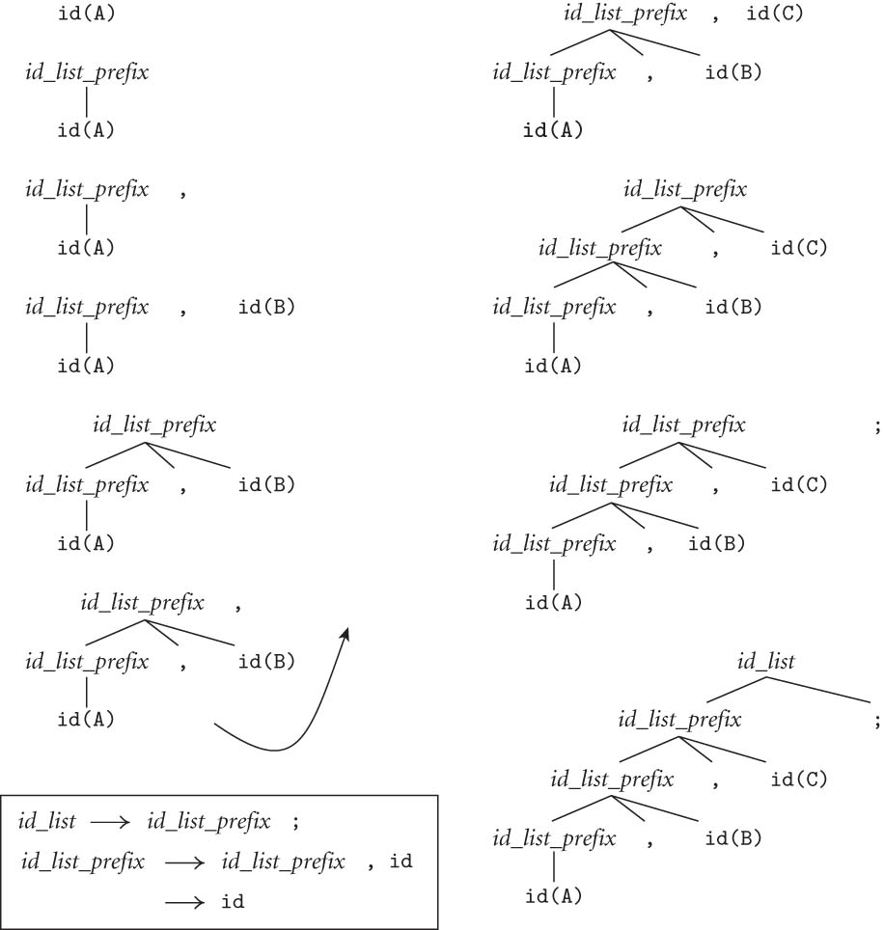

LL(1) does not work with this new grammar, why?

Try a leftmost derivation of A, B, C; with this grammar

Because top-down parsing would require multiple token look ahead

LL(1) does not work in this case because the grammar is left-ambiguous
In order to parse with this grammar using LL, we need to have >1 token look-ahead i.e., LL(*) or LL(k)

2.3.1 Recursive Descent Parsing and LL(1)
LL parsing is also called recursive descent parsing:
    - It’s a top-down, predictive (predicting a unique RHS to expand) parsing method
    - Very intuitive
    - Only works with LL(1)-compatible grammar (i.e., grammars that are NOT left-ambiguous)

Now let’s consider the expression grammar, we need a CFG that
        - unambiguous
        - has correct operator precedence and associativity
        - is right recursive

Grammar 2B extended – can we use this grammar?

Expr Term // add_op rules appear first since they are the lowest precedence
| Expr add_op term // left-recursive rule make it left associative
Term Factor
| Term mul_op Factor
Factor id
| number
| - Factor
| (Expr)
id A-Z
add_op → + | -
mult_op → * | /

Would an LL(1) parser work with this grammar? NO, because both RHS of Expr (i.e., the start symbol) rule can lead us to the token A

Consider making a derivation (or parse tree) for the sentence A+B*C

Since the first symbol is A, with 1 token Look-ahead, we look for a rule or a derivation sequence =>* that will take us from Expr to id. Unfortunately, we found 2:

Expr * id (via Expr->term->factor -> id)
Expr * id (via expr add_op term->term add_op term -> factor add_op term -> id add_op term)
Can we pick the right rule simply based on the current token alone?

No, we’d need to look ahead a little more, we could decide if we could look ahead more tokens.

Our grammar - extended 2B
The good news:
- It is unambiguous.
- It supports correct associativity (i.e., left for +-*/) using left recursive rules
- It supports the correct operator precedence: mul_op over add_op by having add_op rule appear BEFORE mul_op rule.

The bad news:
- It’s left ambiguous due to left recursive rule: ex., E->E + T
- It is NOT LL(1)

Solution?

Use LR(1) or a more versatile parser generator such as ANTLR (uses ALL(*)) , or

Rewrite/extend the grammar further to make it LL(1) (Fig 2.15):

Note: the expression part of this grammar describes the SAME language, but in a way that removes left-ambiguity, i.e., if we see an ID, we know exactly which rule to use.

Production Rule Rule #
--------------------------------------- ----------------------
program → stmt_list $$ 1
stmt_list → stmt stmt_list 2
|
ε 3
stmt → id := expr 4
|
read id 5
|
write expr 6

expr → term term_tail 7
term_tail → add_op term term_tail 8
|
ε 9
term → factor fact_tail 10
fact_tail → mult_op fact fact_tail 11
|
ε 12
factor → ( expr ) 13
|
id 14
|
number 15
add_op → + 16
|
- 17
mult_op → * 18
|
/ 19

This new grammar
- Has additional rules for program, stmt_list, and stmt.
- Changed Expr rules to remove left-recursion, i.e., made it LL(1).
- Still maintain same (and correct) operator associativity and precedence of the previous version, though NOT as intuitive,
- is now an LL(1) grammar.

Example input (a little program):
read A
read B
sum := A + B
write sum
write sum / 2
$$
Try draw parse tree for the above program using LL(1) parsing. i.e., start at the top and select/predict needed productions on the basis of the current left-most non-terminal in the tree and the current input token.

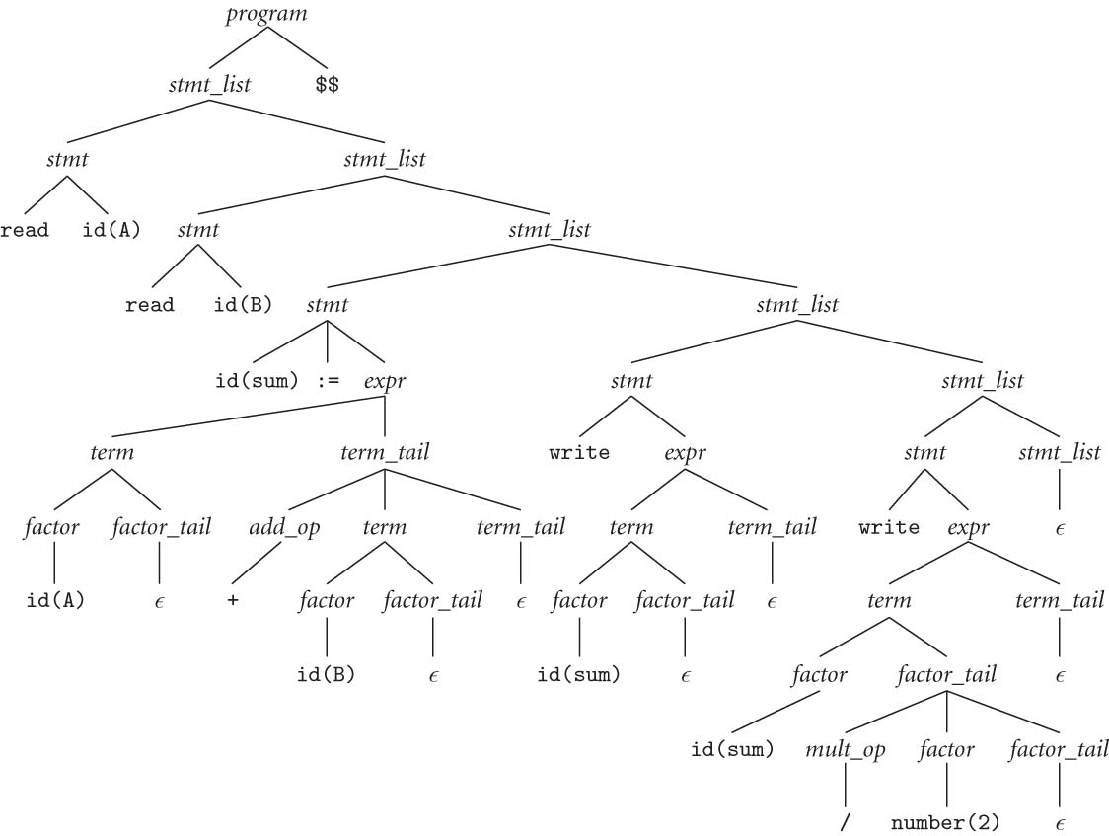

How should we program this?

To implement our LL(1) algorithm with a program, we could create subroutines, one for each non-terminal.
  - In other words, for every rule of the form LHS RHS, the parser contains a function to parse LHS, whose body parses RHS by match (terminal) and subroutine calls (non-terminal).

Notes
- This algorithm is easy and more natural to us programmers. We can write this easily!
- It uses recursion and thus implicitly a (runtime) __stack____ to keep track of all the tokens to be matched and all the non-terminal symbols yet to be expanded.

Alternative implementation - What are the things that determine the parser’s next action during the parsing process?

The current non-terminal that we are trying to expand (when we do it by hand) or complete (when the program is in that subroutine) AND the current token (i.e. the input_token in the example code)

How does the program keep tracks of the remainder of the rules yet to be completed?

By pushing them onto a stack
Table-driven Top-down (LL1) parsing

Use a big loop in which we repeatedly look up an action from a two-dimensional table based on (i.e., indexed on) current leftmost non-terminal (on top of stack) and current input token. The actions are
(1) match a terminal. (Remember, part or all of RHS could be terminal)
(2) predict a production (all numbered), i.e., replacing LHS with RHS
(3) announce a syntax error

Figure 2.19 - LL(1) A parse table for calculator language
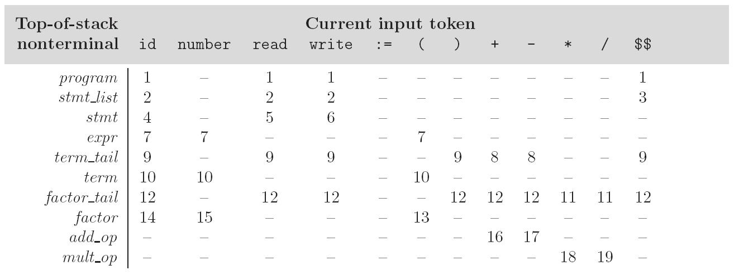

- To keep track of (i.e., following through) the (current) left-most non-terminal, we push the as-yet-unseen (or unmatched) portions of productions onto a stack. Ex.,

Figure 2.20 – Trace of table driven LL parsing of sample program
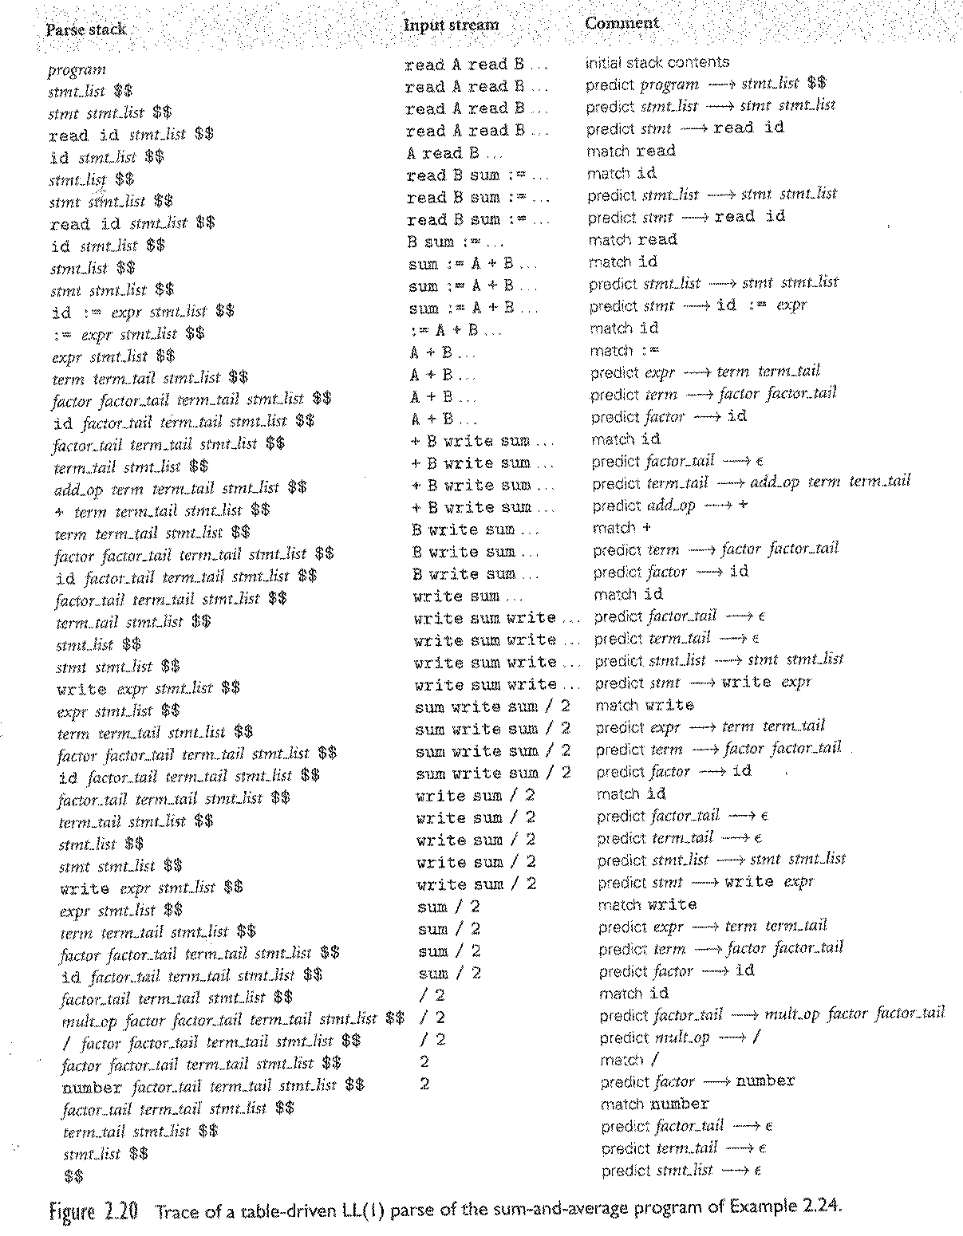

- The key: the stack contains all of the stuff you expect to see between now and the end of the program execution.
- LL(1) parser predict which production (or RHS) to use and there is only one choice.
- Everything is deterministic, no choices involved!
- It’s an error if not everything is matched.

Predict Sets – pre-calculation to make efficient LL(1) parsing

- What is it? A set of terminal symbols associated with each unique production (numbered in our example)
- The combination of LHS non-terminal of the rule (which could be on top of stack) and a symbol in the predict set indicate/determine/predict the application of the production rule
- Applying the rule means:
  - Pop LHS symbol from stack and replace it with the sequence of symbols (a mix of terminal and non-terminal) on the RHS, in PDA computation, or
  - Call a function corresponding to the production, which carrying RHS by matching for terminals and calling functions for non-terminals.

The algorithm to build predict sets is somewhat tedious (for a "real" sized grammar), but conceptually simple, with three stages:
- compute FIRST sets for symbols
- compute FOLLOW sets for non-terminals (this requires computing FIRST sets for some strings)
- compute predict sets or table for all productions

Formally, First/Follow/Predict (* represents sequence of derivation):
- PredictSet (A → X₁ ... X_{m}) == (FIRST (X₁ ... X_{m}) )
∪ (if X₁, ..., X_{m} →* ε then FOLLOW (A))
- First(X₁ ... X_{m}) == First(X₁) ∪ (if X₁-->* ε Then Follow(X₁) …
- FIRST(α) == {a : α →* a β}
∪ (if α =>* ε THEN {ε} ELSE NULL)
- FOLLOW(A) == {a : S →⁺ A a β}
∪ (if S → A β && β ->* ε THEN follow(S) )

For example:

Predict set(program stmt_list $$) // rule 1

First(stmt_list) = { ε, id, read, write}

First($$) = {$$} added since stmt_list is nullable

Predict set(program stmt_list $$) = {id, read, write, $$}

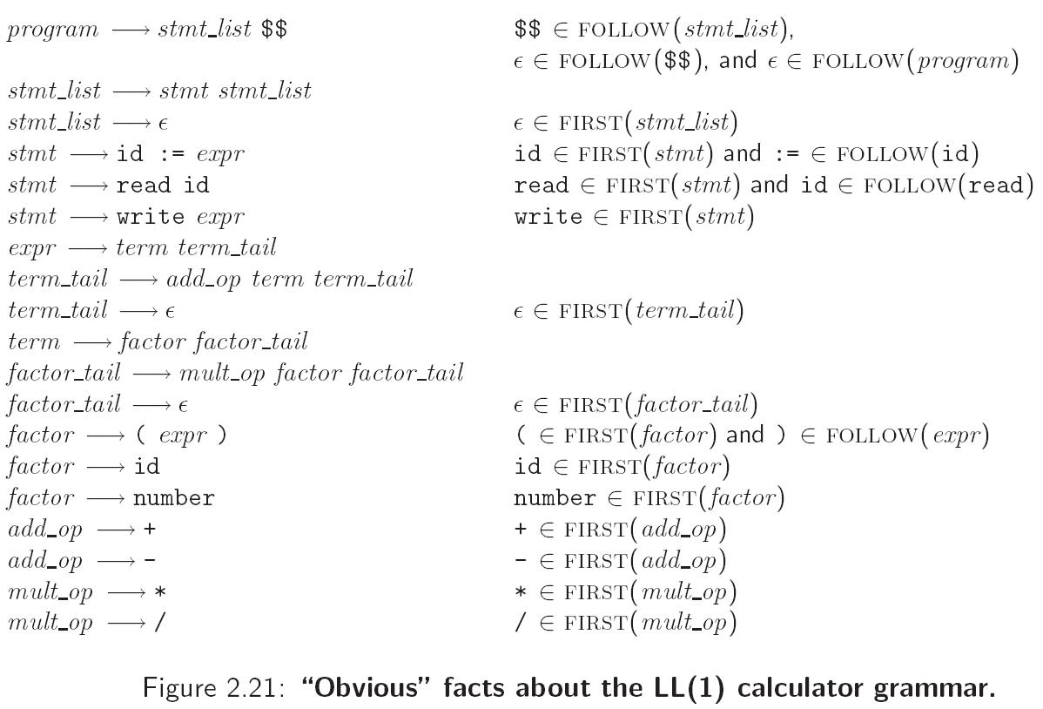

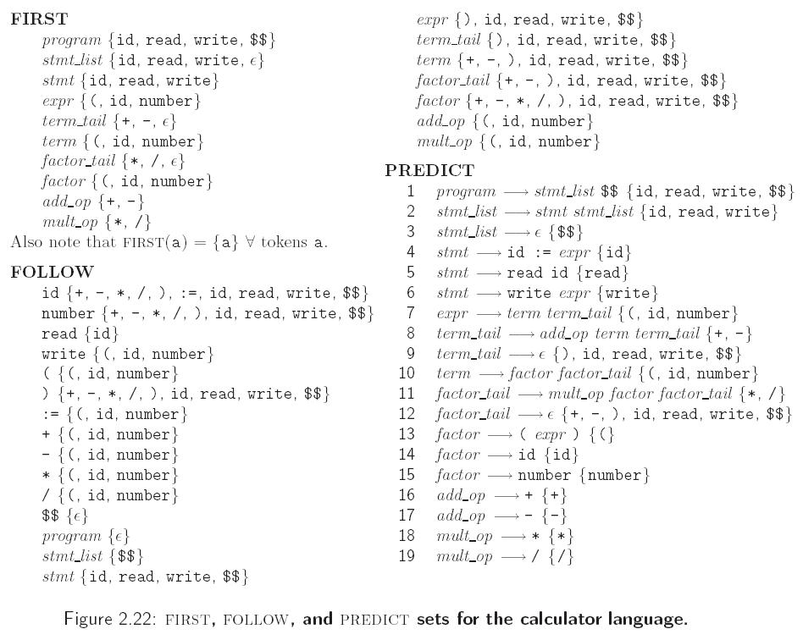

Q:
- Can the same token (i.e., terminal symbol) appears in >1 predict set ? yes, it’s a free country.

Ex.,

A a B // a is in predict set (A a B)
C a D // a is in predict set (C a D)

- Can the same token (i.e., terminal) appears in >1 predict set of production rules with the same LHS? No, we can no longer be free to select the production rules.
Implication this CFG is left ambiguous
Ex.,

A a B // a is in predict set (A a B)
A a D // a is in predict set (A a D)

A simpler Example on making predict set
S -> Ab
| Bc
A -> D
| CA
B -> gA
| ε
C -> dC
| c
D -> h
| i

1. S -> Ab First(Ab) = First(A) = First(D) U First(CA)
First(D) = {h, i} // note we only looked at A since it’s not nullable
// so we will never get to b in First(Ab)
First(CA) = { d, c} // C is not nullable, so no need to find first(A)
so First(A) = {c, d, h, i}
predict(1) = {c, d, h, i}

bool S ()
{
Char temp = cin.peek();
If (strchr(temp, “cdhi”) // not null if temp is one of the 4 letters
{
A();
Match(b);
Return true;
}
Return false
}
2. S -> Bc First(Bc) = First(B) = {g, ε }
since B is nullable (i.e, B* ε), we add Follow(B) = {c} to predict(2)
predict(2) = { g, c }

3. A -> D First(D) = {h, i}
Predict(3) = {h ,i}

4. A -> CA First(CA) = First(C) = {d, c}
Predict(4) = {d, c}

5. B -> gA First(gA) = { g }

6. B -> ε First(ε) = ε, so we find Follow(B) = { c }
// note B only appears in RHS of production #2

7. C -> dC First(dC) = { d }

8. C -> c First(c) = { c }

9. D -> h First(h) = { h }

10. D -> i First(i) = { i } predict(10) = {i}

Is this grammar LL(1)? No, because rule 1 and 2 both has S as var and c in predict set.

More about writing an LL(1) Grammar
Two situations causing a grammar to be non LL(1) – one is easier to fix than the other

      - left recursive rules
example:
id_list → id
| id_list , id // this could span many rules

Solution – replace them with equivalent, non left-recursive rules, ex.,

id_list → id id_list_tail
id_list_tail → , id id_list_tail | ;

We can get rid of all left recursion mechanically in any grammar, but this not as easy as solution for 2.

  - common prefixes (left-ambiguous):

example:
stmt → id := expr
| id ( arg_list )
…

solution: left-factoring

stmt → id stmt_tail
stmt_tail → := expr
| ( arg_list)

We can eliminate common prefixes by left-factoring mechanically. This works for most languages but not all, ex.,

- Some languages are inherently non-LL(k). Ex., the"dangling else" problem in PASCAL:
<stmt> → if <cond> <thenClause> <elseClause>
| <other>

<thenClause> → then <stmt>
<elseclause> → else <stmt> | ε

How do we parse the following?

If A=True then if B=False then C:=80 else C:= 100;

Does the else go with the 1st then or 2nd then ?

- The usual approach, whether top-down OR bottom-up, is to use the ambiguous grammar together with a disambiguating rule that says
  - else goes with the closest then or, to incorporate into grammar rule more generally,
  - or, we can say, when there are >1 possible productions, the first one listed is the one to predict (or reduce/use)

- A better solution - languages (since Pascal) generally employ explicit end-markers, which eliminate this problem. Ex.,
  - in Modula-2, for example, one says:
if A = B then
if C = D then E := F end
else

G := H
end
- Ada says 'end if'; other languages say 'fi'

- One problem with end markers is that they tend to bunch up, when ‘extended if then .. else … is’ used. Ex., in Pascal, normally,

if A = B then …
else if A = C then …
else if A = D then …
else if A = E then …
else ...;

With end markers this becomes
if A = B then …
else if A = C then …
else if A = D then …
else if A = E then …
else ...;
end; end; end; end;

What would the automata need (structure-wise) to process CFG? stack

A quick recap
A scanner (i.e., Lexer) uses a DFA
- it can be specified with a state diagram

An LL parser can be implemented with a one-state PDA (plus some other stuff to make the parse tree)
- A PDA can be specified with a state diagram and a stack
- An LL(*) grammar can be represented by a PDA with one main transition state (i.e., Qloop)!
  - all the transitions are self loops; each corresponds to one particular production. the only difference between them is the choice of whether to push or pop
  - This choice can be made uniquely at each step based on two things: top of stack symbol and next input token – if the grammar is LL(1)
  - the final state is reached by a transition that sees EOF on the input and the stack
  - well, it needs a second accept state, but that's all (it's pretty simple)
  - OK, we may throw in an extra start state.
  - The computation of this PDA is very similar to that of the runtime stack of the recursive implementation of the parser.

    - LR Parsing

Basics: see lrparser.ppt – correction: RHS on page 6 should read LHS

LR parsers are almost always table-driven:
- like a table-driven LL parser, an LR parser uses a big loop in which it repeatedly inspects a two-dimensional table to find out what action to take
- unlike the LL parser, however, the LR driver has non-trivial state (like a real DFA), and the table is indexed by current input token and current state
- the stack contains a record of what has been seen SO FAR (NOT what is expected)

An LR parser is a PDA though different from the PDA in LL
- It has multiple states
- It is a "recognizer," not a "predictor"
- it builds a parse tree from the bottom up
- the states keep track of which productions we might be in the middle

To illustrate LR parsing, consider this grammar, (Figure 2.24):
- program → stmt list $$
- stmt_list → stmt_list stmt
- | stmt
- stmt → id := expr
- | read id
- | write expr
- expr → term
- | expr add op term
- term → factor
- | term mult_op factor
- factor → ( expr )
- | id
- | number
- add_op → +
- | -
- mult_op → *
- | /

This grammar is LR(1)
- It’s left-recursive, which is LR friendlier
- epsilon production was removed for simplicity

Important terms and concepts in LR parsing:

Handle
- A sequence of symbols (terminal and non-terminal) that matches the RHS of some production in an LR grammar
- can be reduced to its corresponding LHS, leading us a step closer to the goal
- Our goal in LR parsing is reducing the entire input stream of tokens into the start symbol

Examples of handle for grammar 2.24:

read id stmt atmt_list stmt

Item: A production with “*" somewhere on the RHS. Intuitively, it marks the progress we have made with regard to a particular production.
- grammar symbols before the “*” are on stack;
- grammar symbols after the “*” represent yet-to-be-seen symbols in the input stream.

Item set:
- A set of items; corresponds to a state of the parser.
- It contains a base and its closures

Example from grammar 2.24:

At the beginning, we are in state 0, which can be represented by the following item set:

Program * stmt_list $$
Stmt_list * stmt_list stmt
Stmt_list * stmt
Stmt * id = expr
Stmt * read id
Stmt * write id

Note that in the above item set, program * stmt_list $$ is the base, while the rest is the closure. In general, given an item:

A α * B β

closure(A α * B β ) is the smallest set that contains
- the item A α . B β and
- every item in closure(B . γ ) for every production B γ in the grammar

LR parser uses

A set of states to keep track of where we are

A symbol stack to keep track of the symbols either directly seen (i.e., terminals) or derived through reduction (non-terminals)

It determines the current action by looking up the current state and current symbol (terminal or non-terminal) on top of stack.

The LR parsing can be represented as a Characteristic Finite State Machine

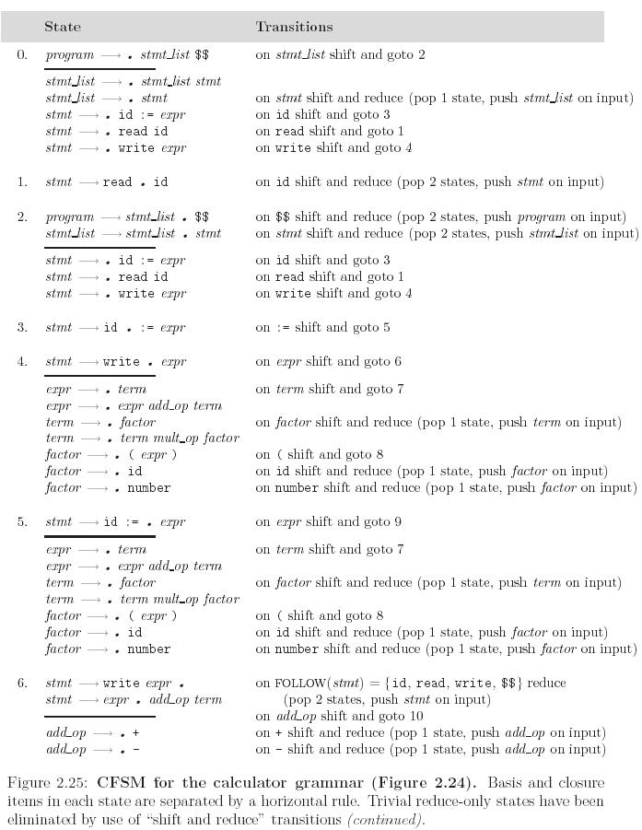

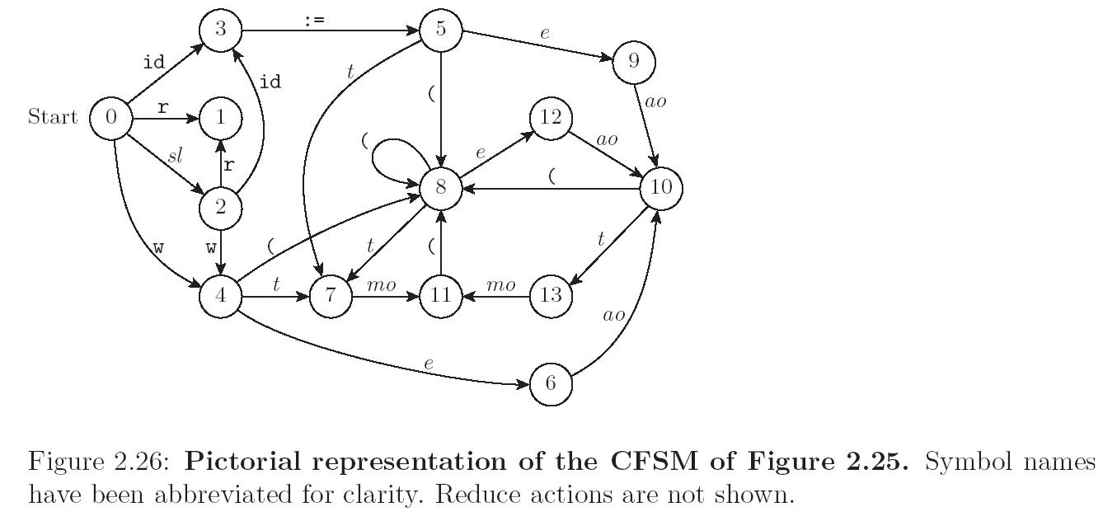

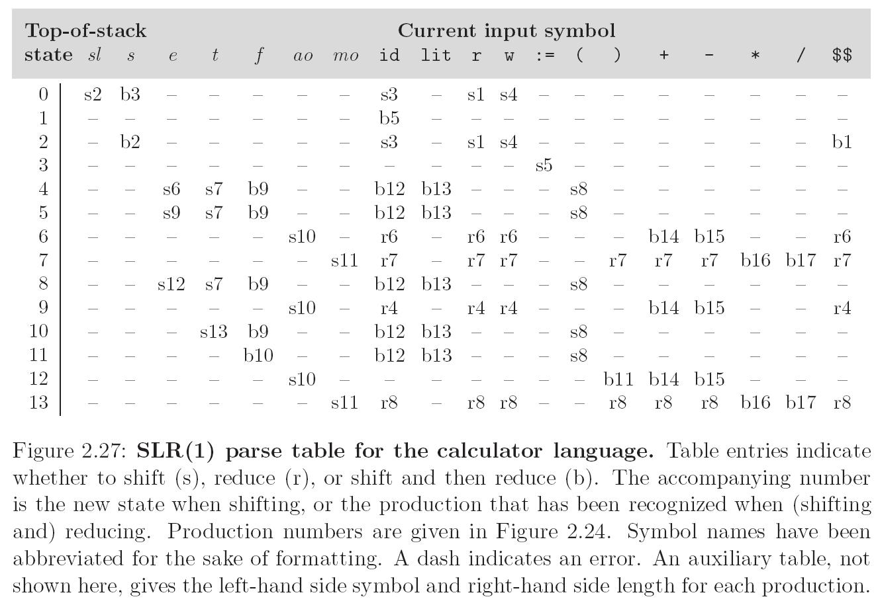

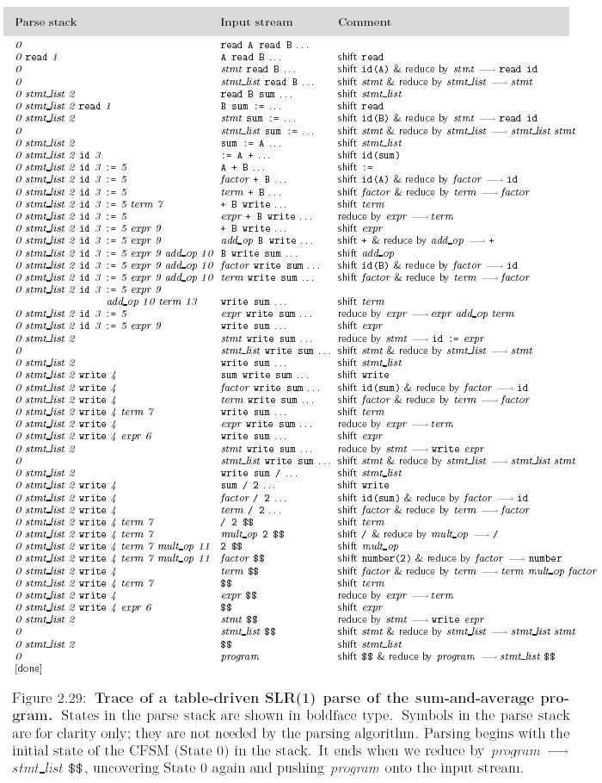9

SLR parsing is based on
- Shift
- Reduce
- Shift & Reduce (for optimization)

